Capstone Project Phase A

**The tool for computational simulation the Earth Energy Absorption and Climate Change**

**24-2-D-39**

**Students:**

Haya Kabishi 211582978 - [Haya.Kabishi@e.braude.ac.il](mailto:Haya.Kabishi@e.braude.ac.il)

Daniella Kadmany 314701699 - [daniella.kadmany@e.braude.ac.il](mailto:daniella.kadmany@e.braude.ac.il)

**Supervisor**:

Dr. Zakharia Frenkel

Table of contents

|  |  |  |  |  |  |  |
| --- | --- | --- | --- | --- | --- | --- |
| 3 | Table of Acronyms …………………………………………………………….……... | | | | | |
| 4 | **Abstract** …………………………………………………………….……....…......... | | | | | |
| 4 | **1.Introduction**…………………………………………………………….……....... | | | | | |
| 5 | **2.Background**…………………………………………………………….……....... | | | | | |
| 5 | 2.1.The parameters that significantly affect weather patterns…………………. | | | | |  |
| 6 | **3.Climate change throughout history** ………………….…….....…………………. | | | | | |
| 6 | 3.1.Temperature change ………………….…….....…………………………… | | | | |  |
| 7 | **4.Earth's Energy Budget** ………………….…….....……………………………….. | | | | | |
| 7 | 4.1.Incoming and Outgoing Radiation …………………….…….....………… | | | | |  |
| 7 | 4.2.Role of the Atmosphere and Surface …………………….…….....…….… | | | | |  |
| 8 | **5.Incoming solar radiation** ………………….…….....………………………...…… | | | | | |
| 8 | 5.1.Impact of Incoming Solar Radiation on Climate and Energy Budget……… | | | | |  |
| 8 | 5.2.Climate system as heat engine …………………….…….....…………… | | | | |  |
| 9 | **6.The role of water in climate systems** ………………….…….....………………… | | | | | |
| 9 | 6.1.Water as a Carbon Sink………………….…….....………………………… | | | | |  |
| 9 | 6.2.Reflective Characteristics of Water ………………….…….....………..… | | | | |  |
| 9 | 6.3.Ocean Circulation Patterns………………….…….....……………………. | | | | |  |
| 9 | 6.4.Feedback Mechanisms Due to Oceanic Warming………………………….. | | | | |  |
| 9 | 6.5Regional Climate Variability in the Great Lakes Region………………….. | | | | |  |
| 10 | **7.Models for the absorption of solar energy in world ocean**…………………….. | | | | | |
| 11 | **8.Available Data** ………………….…….....………………………………………… | | | | | |
| 11 | 8.1.Key parameters world ocean, solar data and Climate Feedback….……..... | | | |  | |
| 11 | 8.1.1.Solar and Atmospheric Energy ………………….…….....… | |  | |  | |
| 11 | 8.1.2.World Ocean …….………….…….....………………………… | |  | |
| 12 | 8.1.3.Atmospheric Dynamics and Climate Feedback…….....… | |  | |
| 13 | 8.2.Existing Data integration and modeling ………………….…….....… | | | |  | |
| 14 | **9.Expected Achievements** ………………….…….....…………………………………… | | | | | |
| 14 | 9.1.Challenges………………….…….....………………………………………… | | |  | | |
| 14 | 9.2.The criteria for our success………………….…….....………………………... | | |  | | |
| 15 | **10.Work Plan** ………………….…….....………………………………………………… | | | | | |
| 15 | 10.1.The work will include ………………….…….....…………………………… | | | |  | |
| 19 | 10.2.The models ………………….…….....…………………………………….. | | | |  | |
| 19 | 10.2.1.Software Building Blocks and Data Flow ………………………. |  | | |  | |
| 20 | 10.2.2.Energy Absorption Simulation Process Flow…………………… |  | | |
| 21 | 10.2.3.Activity ………………….…….....………………………………. |  | | |
| 22 | 10.3.Test plan ………………….…….....………………………………………… | | | |  | |
| 22 | 10.3.1.Technical Test: Data Validation ………………….…….....……… |  | | |  | |
| 22 | 10.3.2.Algorithm Logic Test: Energy Absorption Correlation…………… |  | | |  | |
| 26 | 11.Conclusions………………….…….....……………………………………………… | | | | | |
| 27 | 12.References ………………….…….....……………………………………………… | | | | | |

Table of Acronyms

|  |  |
| --- | --- |
| Acronym | Meaning or definition |
| CC | Climate Change |
| GHG | Greenhouse gas |
| EEI | Earth's Energy Imbalance |
| GMOM | Global mean ocean mass |
| OHC | Ocean heat content |
| SSS | Sea Surface Salinity |
| SST | Sea Surface Temperature |
| GMSL | Global mean sea level |

**Abstract**

Climate changes provide substantial worldwide problems, ranging from severe weather phenomena to disturbances in ecosystems and human civilizations. We are going to create a tool for examination of significance of energy absorption within natural systems, with a particular focus on the Earth's oceans as primary drivers of the climatic thermodynamics. This tool will be applied to calculation of the energy absorption and analysis of its impact on weather patterns and climate change. This study seeks to explain the complex, in many times unpredictable behavior of the weather by revealing of a relationship between energy absorption and climatic changes, combining historical meteorological data, sophisticated analytics, and predictive modeling approaches. We will take into account such variables as solar radiation, albedo, ocean heat content and many others to elucidate the impact of absorbed energy on atmospheric processes and environmental feedback mechanisms. The results will provide an invaluable understanding of the crucial function of energy absorption in influencing climate systems, therefore facilitating more accurate and long-term predictions of weather patterns. The formulated tool will assist scientists, politicians, and communities in devising efficient measures to mitigate and adapt to the growing volatility of the climate.

1. **Introduction**

In recent decades, the frequency and intensity of extreme weather events have escalated significantly, posing substantial challenges to communities worldwide. From intense heatwaves to severe storms and prolonged droughts, these phenomena not only disrupt daily life but also threaten infrastructure, agriculture, and human safety.

Our hypothesis is that absorption and distribution of energy in natural systems have become increasingly critical factors in shaping our planet's climate and weather patterns.

Understanding the complex relationship between energy absorption in natural systems is crucial for developing an effective model for the weather and climatic change forecasting.

We are going to develop a tool for simulating and evaluating energy absorption in natural systems and studying its effects on climate change and weather patterns.

By combining historical meteorological data, advanced analytics, and predictive modeling techniques, we seek to unravel the underlying factors contributing to changing weather patterns and the escalation of extreme events. Our approach focuses on how natural systems absorb energy and how their energy absorption state affects their response to environmental changes, providing a unique perspective on climate dynamics.

The impacts of energy absorption and distribution in natural systems are far-reaching, affecting weather patterns, atmospheric circulation, and ultimately, climate change. These changes have significant consequences for agriculture, public health, water resources, energy production, and biodiversity. Vulnerable populations, including those in coastal areas, arid regions, and low-income communities, are disproportionately affected by the resulting extreme weather events and long-term climate shifts.

By developing an innovative tool for assessing energy absorption and its impact on weather, this project aims to enhance our understanding of climate systems and improve our ability to predict and prepare for future weather patterns. This knowledge is essential for policymakers, climate scientists, and communities as they work to develop effective strategies for climate change mitigation and adaptation in an increasingly volatile environmental landscape.

1. **Background**

CC is any meaningful change in the state of climate lasting for an extended period, either naturally or because of human activities. Anthropogenic activities, reaching back to the beginnings of geological and geodesical history, like burning fossil fuels and deforestation, enhance the concentration of greenhouse gases within the atmosphere, raising the temperature on Earth. These can result in severe effects on natural systems and human societies due to an increase in temperature, sea level rise, frequency and severity of storms, ocean pattern changes, or ocean current changes. These flow into shades of gray that are profound in consequence across the health of the population, use of water, energy production, and biodiversity.[1]

* 1. **The parameters that significantly affect weather patterns**
* **Atmospheric Composition: Greenhouse Gases, Oxygen Levels**

The increased levels of GHGs, mainly due to human activities, increase the absorption capacity of heat in the atmosphere, thereby leading to global warming and changes in weather patterns.[1]

* **Solar radiation: solar brightness, solar cycles**

It influences the weather at a global scale through thermohaline circulation, variations in sea levels, heat redistribution, coastal phenomena, and finally, hydrological cycles and water resources.[2]

* **Circulation: Thermohaline Circulation, Sea Level Changes**

Solar radiation absorbed by the Earth fuels atmospheric processes, while surface albedo modulates the energy budget of the planet darker surfaces absorb more sunlight. [1]

* **Albedo: Ice and Snow Cover, Vegetation Cover**

Albedo is a dimensionless quantity, which determines the fraction of sunlight or other radiation with which the surface reflects in space by different surfaces and the ratio of reflected to incident radiation. Snow and clouds are high albedo, vegetation moderate, and oceans low. Clouds are the main cause of Earth's variability in albedo.[3]

* **Biosphere; Vegetation and Land Use, Human Activity**

Soil moisture is a strong limiting factor to vegetation in the Mediterranean ecosystem. Human-induced climate change will alter precipitation and temperature patterns that affect the productivity, biodiversity, and biogeochemical cycles of ecosystems, feeding back to regional weather through changes in evaporation, albedo, and carbon cycling.[4]

1. **Climate change throughout history**

Throughout history, Earth's climate has varied from hot and humid to cold glaciations. Over the past millennia, there existed a stable climate that gave rise to farm and urban growth. Human-induced emissions of greenhouse gases have triggered tremendous warming, pointing out to global temperatures, melting of glaciers, and rising of sea levels.

* 1. **Temperature change:**
* **Global warming**

Global warming is the long-term increase in warming of the surface temperature of the Earth, primarily due to human activities, particularly through the combustion of fossil fuels raising levels of GHGs in the atmosphere.

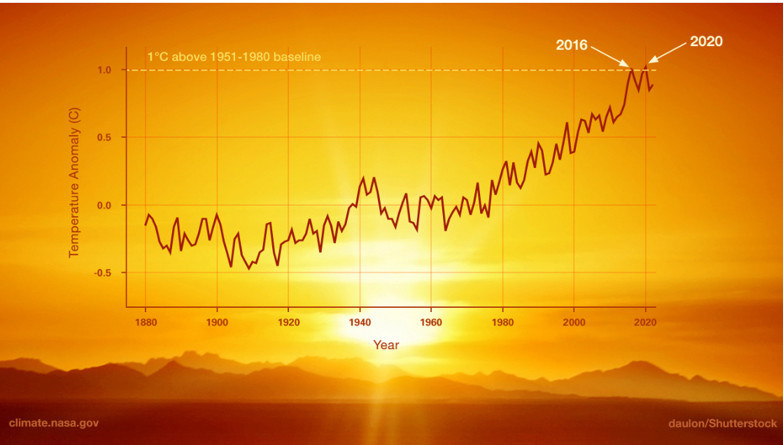

Fig 1: This graph shows a very high rate of warming, with 2020 tying with 2016 as the hottest year on record.[5]

* **Sea Level Rise**

The melting of glaciers and the thermal expansion of ocean water raise sea levels. More significant locally is the apparent sea level change affected by the rise or fall of landmasses.[6]

* **Temperature Increases Across Regions**

The global temperature records show that all continents and oceans have warmed up, though at different rates, which is due to several factors including changes in land use, which modifies the amount of solar energy absorbed by the earth.[6]

* **CO2 concentration annually**

The GHG results from the combustion of fossil fuels and natural sources. The levels of this gas have increased since the Industrial Revolution due to human activity, survived in the atmosphere for centuries, and continued to influence the climate.

Carbon dioxide, upon entering the atmosphere, lingers for a longer period. Some of them are absorbed by plants and oceans, and about half of the carbon dioxide remains in the atmosphere.[6]

1. **Earth's Energy Budget**

The Earth's energy budget refers to the movement of energy within the climate system. Since at least 1970, the climate system has been absorbing surplus energy as a result of a continuous disparity in energy flows.   
The Earth is constantly exposed to substantial quantities of energy daily, primarily in the form of sunlight. Clouds, aerosol particles, and highly reflective surfaces such as snow and ice can reflect approximately one-third of the sun's rays into space. The remaining energy is absorbed by the land, sea, ice, and atmosphere. The primary factor responsible for the overall temperature change is the ocean's exceptional capacity to absorb heat, accounting for a significant 91% contribution. Earth's climate has changed over the industrial period, as manifested by increased global surface temperature and rising sea levels.

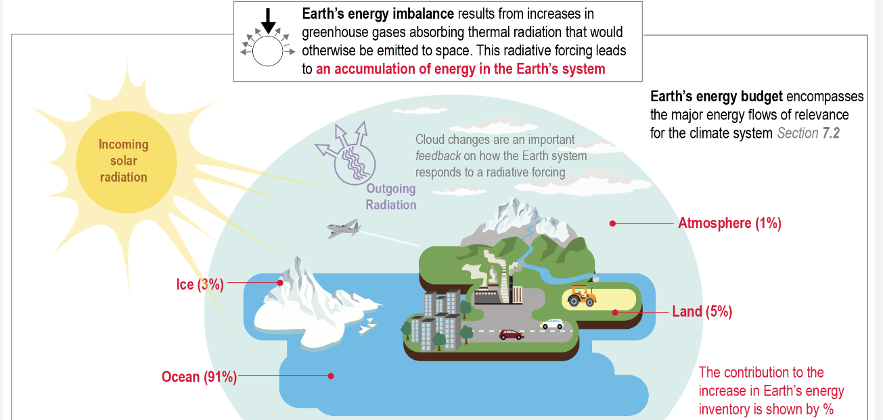

Fig 2: The graph shows that most of the excess energy due to the GHG effect is stored in the ocean, followed by land, ice, and the atmosphere**.[7]**

* 1. **Incoming and Outgoing Radiation**

The Earth absorbs incoming solar radiation in the form of longwave radiation and re-emits it as shortwave radiation. Clouds, atmospheric particles, and Earth's surface reflect 30% of incoming radiation, while the remaining 70% is absorbed, causing the Earth to warm.

* **Outgoing Longwave Radiation**

The Earth releases longwave radiation to maintain energy equilibrium. Every object, including the Earth, releases energy because of its temperature.[7][10]

* 1. **Role of the Atmosphere and Surface**

Role of the Atmosphere and Surface

Absorption and Emission The atmosphere and Earth's surface assimilate, deflect, and discharge radiation. The surface is heated by solar energy, causing the air above it to warm up, and both emit longwave radiation.[8]

* **Reflection:** Clouds and atmospheric particles could reflect a portion of the solar radiation that reaches the Earth's surface, which is referred to as albedo. Surfaces with high albedo, such as ice and snow, reflect a greater amount of sunlight compared to darker surfaces like forests and oceans.[9]
* **GHG Effect** is the process in which GHG, such as carbon dioxide, methane, and water vapor, trap and re-radiate outgoing longwave radiation, thereby sustaining a livable climate on Earth.

**After researchers, we decided to explore:** how the absorbed solar energy affects CC We selected the world ocean as the main player of the absorption.

1. **Incoming solar radiation**

Solar radiation is absorbed in the form of heat energy on Earth's surface and the atmosphere, influencing climatic and weather phenomena. Surface properties and atmospheric conditions affect absorption, with high albedo causing cooling and low albedo causing warming. Clouds also impact radiation balance, reflecting and absorbing it. Earth's inclination and trajectory affect solar radiation, affecting climate patterns. The Earth releases absorbed solar energy as longwave radiation, partially captured by greenhouse gases, contributing to the GHG effect. [2][5][3][8]

Fig 3: This graph shows the global mean energy budget of the Earth with and without clouds, highlighting the magnitudes and uncertainties of energy components, and quantifying cloud effects on the energy budget.[7]

* 1. **Impact of Incoming Solar Radiation on Climate and Energy Budget**
* **Angle of incidence**
* Near the Equator: Sunlight hits at a steep angle, leading to intense radiation and efficient warming.
* Near the Poles: Sunlight hits at an oblique angle, resulting in less intense radiation.
* **Seasonal Variations**
* Tilt and Orbit: The Earth's axial tilt and elliptical orbit cause seasonal changes in solar radiation, affecting global climate patterns.[12][13]
  1. **Climate system as heat engine**

The climate system functions as a massive planetary heat engine, powered by solar radiation absorption and cooled by space emission. Heating occurs on warm tropical surfaces, while cooling occurs in colder troposphere's, primarily at higher latitudes.[10]

Fig 4: This graph shows how the Sun provides energy, which is partly used to drive natural processes on Earth, with the rest radiated back into space.[7]

1. **The role of water in climate systems**

In its various forms, water plays a central role in regulating the Earth's climate. From vast oceans to large freshwater bodies, water influences global and regional weather patterns, energy balances, and carbon cycles.

* 1. **Water as a Carbon Sink**

The oceans are a crucial carbon sink, absorbing around 25% of human-caused CO2 emissions. The absorption process consists of two mechanisms: physical, which involves the dissolution of CO2 in seawater, and biological, which involves photosynthesis by marine organisms. Various factors, including water temperature, salinity, and biological activity, affect the efficiency of oceans in absorbing and storing carbon. Modifications in ocean circulation and temperature can influence the ability of oceans to assimilate CO2, which has consequences for the regulation of global climate.[14]

* 1. **Reflective Characteristics of Water**

Water surfaces exhibit the phenomena of reflection and absorption of solar radiation, which is determined by their natural features. The albedo of water changes depending on the angle at which solar rays hit it and the condition of the water's surface, whether it is calm or rough. Still, water exhibits a reduced albedo, reflecting a smaller amount of sunlight, whereas turbulent water, characterized by waves and ripples, enhances light scattering, resulting in an elevated albedo. This variability impacts the balance of energy at the Earth's surface, thereby contributing to variations in climate across different regions.[14]

* 1. **Ocean Circulation Patterns**

Ocean currents play a crucial role in controlling global climate by effectively distributing heat and nutrients. Common patterns consist of:

* **Gulf Stream:** The Gulf Stream carries warm water from the Gulf of Mexico to the North Atlantic, exerting a significant impact on weather patterns and climate conditions in Europe and North America.
* **North Atlantic Drift:** The Gulf Stream's influence is extended, resulting in the moderation of Northwestern Europe's climate
* **Antarctic Circumpolar Current:** The world's most powerful oceanic current, known as the Antarctic Circumpolar Current, surrounds Antarctica, linking the Atlantic, Pacific, and Indian Oceans, and dispersing heat on a global scale.[10]
  1. **Feedback Mechanisms Due to Oceanic Warming**

Oceanic warming activates multiple feedback mechanisms that have a chance to intensify the impacts of climate change. For example, when the temperature of the oceans increases, they can release a greater amount of carbon dioxide, which reduces their ability to act as carbon sinks. The process of polar ice melting reduces the albedo, which in turn results in a higher absorption of solar radiation and contributes to additional warming. In addition, elevated water temperatures have the potential to modify atmospheric conditions, leading to a rise in the occurrence and severity of extreme weather phenomena such as hurricanes and typhoons. These feedback mechanisms highlight the interdependence of oceanic and atmospheric processes in climate dynamics.[14]

* 1. **Regional Climate Variability in the Great Lakes Region**

The Great Lakes region faces substantial regional climate variability because of its expansive freshwater bodies. The lakes exhibit temperate conditions, resulting in relatively higher temperatures in the surrounding regions during winter and lower temperatures during summer. Additionally, they have an impact on the distribution of precipitation, leading to the occurrence of lake-effect snow during winter and higher levels of humidity during summer. Understanding regional climate dynamics is crucial due to the impact of temperature and precipitation variability on local ecosystems, agriculture, and water resources. [14][10]

1. **Models for the absorption of solar energy in world ocean**

Understanding the absorption of solar energy by water requires the integration of advanced designs, scientific expertise, and data analysis. There are several main methods and tools employed to compute and predict the solar radiation impacting bodies of water and their maximum levels

* **Numerical models:** Advanced numerical models predict solar radiation's impact on water bodies, considering atmospheric data, surface properties, and angles, aiding in energy allocation, climate assessment, and ecosystem evaluation.[10]
* **Climate change models:** Complex climate simulations forecast future conditions based on atmospheric composition, ocean currents, land surface processes, and solar radiation, crucial for understanding climate change impacts, guiding policy choices, and informing strategies for reducing and adapting to its effects.[17]
* **Thermodynamic models:** Mathematical equations model the energy and mass exchanges that occur in Earth's climate system, including heat transfer, phase changes, and chemical reactions in the atmosphere, oceans, and land. These models estimate climate dynamics and provide information for climate change strategies.[9]
* **EEI models:** provide essential data for understanding the energy absorbed by the ocean and overall climate dynamics.[14]
* **OCEAN5 System:** OCEAN5 is a complex ocean reanalysis system that utilizes observations to calculate the ocean's heat content and absorption of solar energy. It has become known for its accuracy in monitoring oceanic conditions.[15]
* **ARGO Float Data Integration:** The ARGO project includes a worldwide network of remote floats that collect data on the temperature and salinity of the upper 2000 meters of the ocean. This data is needed for calculating the ocean's temperature and absorption of solar radiation.[11]
* **Radiation Measurements from Space Complementing OHC:** This method integrates space-based radiation measurements with OHC data to offer a comprehensive understanding of the Earth's energy balance and the dispersion of solar energy in the ocean.[16]

1. **Available Data**

**Key Factors and Analysis in Solar Energy Absorption and World Ocean Studies**

It is well known that the solar radiation significantly influences on many climatic parameters. Feedback of several of them includes effect on the solar radiation absorption/reflection properties. To comprehend these interactions and ascertain the most effective measurement techniques, we have opted for the ERA5 dataset. ERA5 provides extensive data on all pertinent variables for the previous decade, encompassing every month and hour of the day.

We have chosen crucial variables to comprehend those complex interrelationships among solar energy, atmospheric phenomena, oceanic dynamics, and climate feedback mechanisms. The oceanic and hydrological processes, such as evaporation and precipitation, are vital for the transfer of energy within the climate system.

Below we provide a short review of how these parameters affect solar radiation. In the subsequent sections, we will thoroughly examine each parameter. [2] [5[6][11][14][24]

* 1. **Key parameters world ocean, solar data and Climate Feedback**
     1. **Solar and Atmospheric Energy**
* **Solar irradiance:** Solar irradiance, the power received from the Sun per unit area, significantly influences Earth's energy balance and climate. It varies due to Earth's orbit, solar activity, and atmospheric composition, affecting climate patterns and local weather. Understanding surface solar irradiance is crucial for analyzing energy transfer between the atmosphere and land/ocean surfaces [2][7][14]
* **Solar radiation:** Solar radiation in Earth's energy budget involves absorption, reflection, and re-emission by surface and atmosphere. This balance, crucial for temperature regulation, is influenced by greenhouse gases, clouds, aerosols, and surface albedo. Changes impact global and local climates, affecting temperature patterns, atmospheric circulation, and plant growth. [1][11][16]
* **Temperature:** The Temperature, key for climate change assessment, reflects conditions experienced by humans and ecosystems. It's sensitive to local and global climate factors. Changes affect agriculture, water resources, biodiversity, precipitation patterns, and extreme weather events. Even small average temperature increases can trigger significant climate system responses. [1][4][5][6]
* **Surface Net Solar Radiation:** Surface net solar radiation, the solar energy absorbed by Earth's surface after reflection and atmospheric absorption, influences surface temperatures, evaporation, and ecosystem productivity. Changes impact regional climate, including monsoon patterns, drought occurrence, and vegetation growth. It's key for assessing climate change impacts and in climate modeling. [1][2][4][8]
* **Incoming Solar Radiation:** amount of solar radiation reaching the top of the Earth's atmosphere, before it interacts with clouds or aerosols.
  + 1. **World Ocean**
* **SST:** The SST is the boundary between the ocean and atmosphere. It can be used to understand the flows of energy between the two and hence the role of the oceans in shaping the weather and climate, and vice versa. Warmer SSTs can enhance evaporation rates, influence weather systems, and alter climate patterns. [19]
* **Ocean Currents:** Ocean currents, influenced by gravity, wind friction, and water density variation, are a crucial component of ocean circulation, transferring heat from Earth's equatorial areas to the poles and influencing coastal climates and atmospheric circulation [21]
* **Albedo:** Albedo measures the degree to which Earth's surface reflects light, thereby impacting the quantity of solar energy that is absorbed. Changes in albedo, resulting from the melting of ice or changes in land use, have the potential to greatly impact the overall global energy balance. Lower albedo means more solar energy is absorbed, leading to higher surface temperatures. [3][6]
  + 1. **Atmospheric Dynamics and Climate Feedback**
* **Air pressure:** Air pressure is a fundamental and essential atmospheric parameter that has a significant impact on weather patterns and the dynamics of climate. Changes in atmospheric pressure generate wind patterns and impact the development and direction of weather systems. Lower air pressure typically leads to stormy weather, while higher pressure often results in calmer conditions.
* **Clouds and Humidity:** Humidity, or the amount of water vapor in the air, is a key factor in cloud formation Clouds have a significant impact on the Earth's energy balance. They reflect certain amounts of the solar radiation back into space, which helps to cool the Earth. However, they also trap heat in the atmosphere, which contributes to global warming. The quantity and nature of cloud cover directly influence the absorption of energy at both local and global scales. [7]
* **Wind Speed and Direction:** The movement of air, known as wind, causes the mixing of the ocean's surface, aiding the dispersion of solar energy that has been absorbed into the upper layers of the ocean. This procedure effectively prevents the surface from becoming excessively hot and improves the overall absorption by evenly spreading heat further into the water column. Wind stress exerted on the surface of the ocean creates currents that can transport warm water to various areas. Strong winds can enhance evaporation, cooling the surface, and modifying the heat exchange between the ocean and atmosphere. [22]
* **Precipitation:** Precipitation can impact the configuration and density of aerosols in the atmosphere. And it can remove aerosols, which are small particles that are suspended in the atmosphere and can either disperse or absorb solar radiation. The elimination of aerosols can result in alterations to the Earth's radiative balance, as aerosols generally have a substantial impact on both cooling the atmosphere through sunlight reflection and warming it by absorbing heat. High precipitation rates can lead to reduced aerosol concentrations, affecting local and regional climate conditions [23]

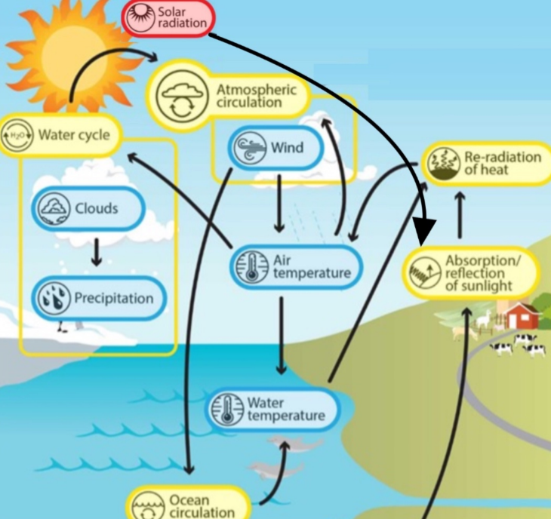

Fig 5: The graph shows how these parameters collectively influence the Earth's energy balance, climate patterns, and weather systems.[12]

* 1. **Existing Data integration and modeling**
* **Numerical models:**
* Using data sets to develop models that predict
* effect of solar radiation and water absorption on the climate.
* combines improved estimates of ocean heat content and climate scenarios [16].
* **Climate change models:**
* Climate Change Models focus on monitoring OHC and EEI to gain a precise picture of climate dynamics.
* Using integrated water and solar data to simulate future climatic scenarios.
* Verifying geodetic estimates by comparing them with Argo data and CERES observations. [11][15]
* **Thermodynamic models:**
* Thermodynamic models are used to estimate the EEI in order to gain a better understanding of global warming.
* Assessing variations in OHC.
* Estimating the changes in sea level caused by the expansion of water due to changes in temperature and differences in salt.
* Enhancing climate forecasts through the integration of many data sources.
* Using space-based methods to monitor the heat content of the ocean and the imbalance of energy on Earth.[11]
* **Error Propagation and Uncertainty Calculation:**
* Using data obtained from satellites to observe changes in sea level and ocean mass.
* Quantifying inaccuracies in the time series of GMSL and GMOM.
* Utilizing error propagation to estimate uncertainty in OHC and EEI.
* Using statistical techniques to determine the level of uncertainty in measurements of heat content.
* Using precise algorithms and implementing bias corrections to ensure the accuracy of climate modeling. [11][14]

1. **Expected Achievements**

The main goal of this research is to create a simulation tool for accurately calculating the amount of energy absorbed by oceanic and atmospheric systems. The toll will specifically examine changes in temperature at different levels and take into account the relationship between energy absorption and weather conditions.

* 1. **Challenges**
* **Data availability and quality:** The tool's computations may contain errors due to incomplete or inconsistent data, so it's imperative to create procedures for efficiently managing damaged or missing data.
* **The task of creating a precise tool** to calculate the amount of energy absorbed in oceanic and atmospheric systems is naturally complex. Even very sophisticated models can display substantial margins of error as a result of the variability and unpredictability of energy interactions between air and water.
* **Long-term projections** Predicting the long-term impacts of energy absorption on climate patterns is another challenge. The tool needs to be capable of simulating long-term trends and interactions in a way that is both accurate and reliable.
* **Uncertainty in Environmental Parameters:** a significant challenge, particularly in relation to the variable quantities of air and water at different temperatures, the depth of water, and the precise absorption of energy within these depths. Lack of precise measurements of these parameters limits complete modeling of intricate interactions among air, water, and energy, which may result in substantial gaps in our knowledge.
* **Tool Complexity:** Developing a tool capable of accurately calculating energy absorption in oceanic and atmospheric systems is inherently complex. This requires integrating multiple environmental factors and ensuring the accuracy of the results.
  1. **The criteria for our success:**
* **A thorough review of existing literature:** Performing an in-depth review of current research and models about the process of energy absorption in natural systems. Documentation of accessible data sets, current theories of energy absorption and distribution, and their formal representations.
* **Comprehensive datasets:** Gather and document diverse historical data sources on energy absorption, weather patterns, and atmospheric conditions.
* **Tool Development and Accuracy:** Tool development is the process of identifying and selecting suitable scientific models to analyze the relationship between energy absorption and weather factors. Create a mathematical model to replicate the process of energy absorption and its impact on climate change. the tool will use surface-level data to calculate energy transfer.
* **Data analysis:** The success of our tool is measured by its ability to accurately simulate energy absorption and predict climate impacts, validated through alignment with established models and consistency with observed data trends in charts, confirming the tool's precision in reflecting real-world climate dynamics.

1. **Work Plan**

We are going to create a new energy absorption simulation tool integrating environmental data and to apply this tool for CC forecast.

Fig 6: Research concept

* 1. **The work will include:**

1. Divide the Earth into uniformly sized squares. This step is required for integration of the energy through the Earth surface. As such we will utilize a code [26] to allow us to analyze energy distribution across various regions with precision. Furthermore, to make our energy absorption estimates more accurate, we intend to investigate ways to improve our methodology that are influenced by current modeling techniques.

Fig 8: Output (Map after division (

* **Location in a Recognizable Shape**: A location that looks like an island or continent means it's on land.
* **Location in an Irregular Pattern:** The location is probably in water if it's spread out or hard to see, or if it's close to the edge of a continent.
* **Red Numbers:** These numbers are identifiers for each square, making it easier to reference specific locations during analysis.
* **The colors represent the autocorrelation of temperature on the map:**
  + **Darker Colors (Dark gray or Black):**

Higher Autocorrelation

* + **Lighter Colors (Light gray or white):**

Lower Autocorrelation

What This Means in our Research**:**

* **High Autocorrelation Regions:** Darker regions on the map could be areas where the climate is more stable, and temperature patterns are more predictable.
* **Low Autocorrelation Regions:** Lighter regions could indicate areas with more volatile or unpredictable temperature patterns.

1. We will use the data set provided by CoolProp [25], which contains a detailed 5-year record of thermodynamic information for more than 100 fluids, including water, refrigerants, and industrial gases. The datasets, which contain useful data such as critical density, saturation pressure, and temperature, will be utilized to model energy absorption in various settings. In addition, the ERA5[24] climate reanalysis data will provide a necessary environmental system, including factors like temperature and solar radiation, that accurately mimic situations in the real world. In order to confirm the effectiveness of our approach, it is crucial to assess the energy estimation model by analyzing significant metrics over a given period, ensuring that the model properly represents the dynamics of energy absorption without overestimating or underestimating it. This comprehensive approach will ensure the preservation of precision under different conditions in nature.

Fig 7: CoolProp data set Example

1. We will develop and present the mathematical formulas necessary for calculating energy absorption and distribution across various Earth systems. These formulas will be derived from established models and datasets, such as ERA5 and Cool Prop, ensuring that our approach accurately represents the complex dynamics of solar and atmospheric energy, oceanic heat content, and other climatic factors integral to our research.

Formulas for calculating parameters: These parameters exist in the database with which we can calculate the data described in our work plan

* **Solar and Atmospheric Energy**
  + **Solar Irradiance: $I_{surface= }I_{direct }$** + $I_{diffuse}$– $I_{reflected }$

Where:

$I_{direct}$ = Direct solar radiation, which is the sunlight that reaches the surface without being scattered. $I_{diffuse}=$ 
 Diffuse solar radiation which is the sunlight that is scattered in all directions by particles in the atmosphere and still reaches the surface

$I_{reflected}=$ Reflected solar radiation, which is the portion of the incoming solar radiation that is reflected back into space by the Earth's surface [28]

* + **Temperature:** T=T0+ΔT

Where:

T0 is the initial temperature and ΔT is the change in temperature over time, which can be modeled using differential equations.[30]

* + **Net Solar Radiation**: ${ S}_{net}$ = $S_{incident }$ $×\left(1-α\right)$

Where: $S_{incident }$ = Total incident solar radiation (W/m²) on a horizontal plane at the Earth's surface (both direct and diffuse),

α = Albedo [28]

* + **Incoming Solar Radiation at TOA**: $I_{TOA}$ = $I_{accumulated /t }$**​**

Where:

$I_{accumulated= Accumulated solar radiation over the given period}$

t= Accumulation period in seconds [28]

* **World Ocean**
  + **Albedo:** α = $\frac{I reflected}{I incident }$

Where:

I reflected​ = Solar radiation reflected by the Earth's surface (W/m²),

I incident= Incident solar radiation at the Earth's surface (W/m²). [28]

* **Atmospheric Dynamics and Climate Feedback**
  + **Air Pressure:** P = ρ× $R_{d}$ ​×T

Where:

ρ = Air density

$R_{d}$ ​ = Specific gas constant for dry air

T = Temperature [28]

* + **Clouds and Humidity:**

**Total Cloud Cover: $C_{total}=$** 1- $\prod_{i}{\left(1-C_{i}\right)}$

Where:

$C_{total}$ = Total cloud cover, representing the fraction of the grid box covered by clouds,

Ci = Cloud fraction at model level i, where cloud fractions range from 0 (no clouds) to 1 (completely cloudy), [28]

**Humidity:** RH=100X $\frac{e}{s^{e}}$

Where:

Rh: relative humidity percent.  
e: is the current vapor pressure.

$s^{e}$: is the saturated vapor pressure at the given temperature [29]

* **Wind Speed and Direction:**

**Wind Speed:** wind speed = $\sqrt{U^{2}+V^{2}}$

**Wind Direction**: θ = $arctan\left(\frac{V}{U}\right)$ 
Where:  
 U = Eastward wind component

V = Northward wind component [28]

* **Total precipitation: $P_{total }$** = $P_{ls}$ + ${ P}_{conv}$ combined amount of liquid and frozen water (rain and snow) that reaches the Earth's surface

Where:

[28]

* 1. **The models**
     1. **Software Building Blocks and Data Flow**

This diagram depicts a modular software architecture specifically developed for energy absorption analysis. The system includes dependent core modules responsible for data consume, processing, and output visualization.

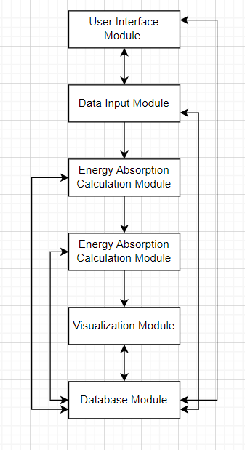

* **Module for user interface**: The Front end is responsible for user interactions.   
  Input data is transmitted to the data input module, processed results are received for display, and the visualization module is interfaced with to present visual outputs.
* **The Data Input Module:** is responsible for managing the collection, validation, and pre-processing of data.   
  Gets input from the user interface module, sends processed data to the energy absorption calculation module, and interacts with the database module to store and retrieve data.
* **Calculation of Energy Absorption Module Function:** Computing energy absorption calculations.   
  Receives data from the data input module, transmits results to the visualization module, and stores them in the database module. In the case of many modules, they may share data to perform iterative calculations at the same time.
* **Data Visualization Module:** Generates graphical depictions of the calculated data.   
  Retrieves processed data from the module responsible for calculating energy absorption and transmit visual outputs to the user interface module for presentation.
* **Database Module Function:** serves as the primary repository for all input data, transitional data, and final results. Interfaces are established with the data input module and energy absorption calculation module to simplify the storing and retrieval of data.
  + 1. **Energy Absorption Simulation Process Flow**

This flow chart displays each stage involved in simulating energy absorption and its consequential effects on climate change, starting from the collecting of data to the interpretation of the outcomes achieved.

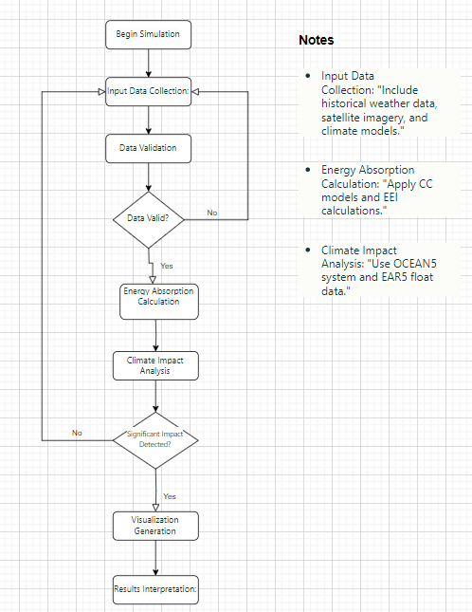

* **Commence Simulation (Start):** Initiates the procedure.
* Data Collection: Acquires historical meteorological data, satellite photos, and climatic computer models.
* **Data validation** involves verifying the accuracy and completeness of data.
* **Energy Absorption Calculation:** uses thermodynamic models and EEI computational methods to calculate energy absorption.
* **Analysis of Climate Impact:** Examines the influence on climate patterns by using data from the CoolProp and EAR5 float.
* **The Visualization Generation** function generates graphical representations of the obtained results.
* **Results Interpretation:** Analyses results to determine their climate implications.
* **Generate Report (End):** Finalists the operational procedure.
  + 1. **Activity**

The activity diagram illustrates the workflow of a simulation tool designed to predict climate change. It is organized into four main pools representing different roles and functions: User, System, Data Processing, and Output Generation.

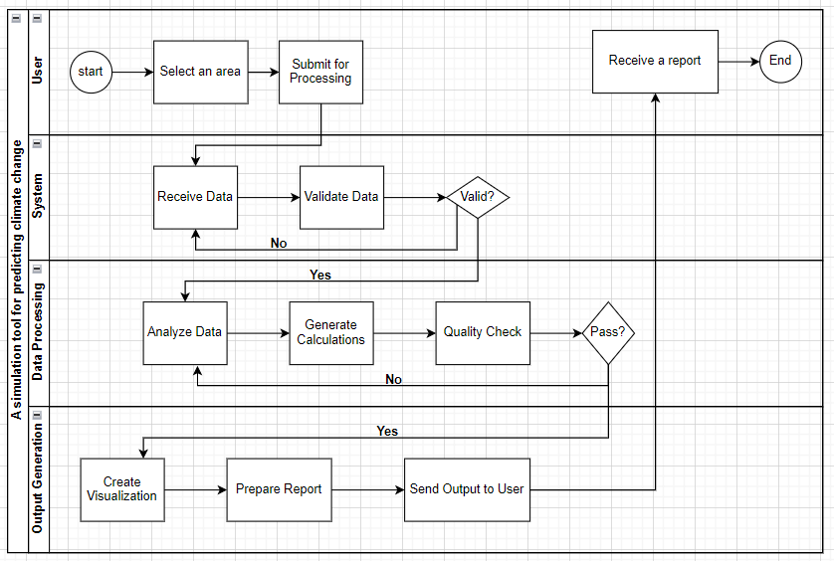

* **User:**
  + - Start Process: Initiates the main activity (e.g., data input, selection).
    - Select an area: The user selects the required area for the process.
    - Submit for Processing: The user submits inputs for system handling.
* **System:**
  + - Receive Data: The system receives input data from the user.
    - Validate Data: Checks the accuracy and completeness of the input data.
    - Process Data: Conducts necessary calculations or operations based on user input.
    - Save Results: Saves processed data for further analysis or use.
* **Data Processing:**
  + - Analyze Data: Performs data analysis using statistical or algorithmic methods.
    - Generate Calculations: Executes specific calculations required for analysis.
    - Quality Check: Ensures the processed data meets predefined quality criteria.
* **Output Generation:**
  + - Create Visualization: Generates graphs, charts, or maps to represent the results.
    - Prepare Report: Compiles findings into a structured report format.
    - Send Output to User: Delivers the final report or visualization to the user.
  1. **Test plan**
     1. **Technical Test: Data Validation**

It is crucial to do technical checks to verify that the system accurately reads, processes, and produces the data used for our study. The tests mainly assess the operational aspects of data management and the proper functioning of the software components responsible for reading and verifying the data. To establish a dependable basis for future algorithmic evaluations, the main goal is to verify that the data is read accurately and the functions execute effectively.   
  
The purpose of these tests is to verify the accuracy, completeness, and proper formatting of the data that is entered into the system. We shall undertake:

* DATA validation checks verify the accuracy of data reading and detect any faults, such as missing numbers or inappropriate formats. Consistency checks guarantee the stability of the data when it is read many times.
* We conduct function output validation to verify that certain functions responsible for handling and displaying data generate accurate outputs. This involves verifying the precision of generated summaries and statistical calculations by comparing them to expected values.
* The results of all tests will be thoroughly documented, including the specific items evaluated, the anticipated outcomes, and the actual findings, therefore ensuring full record of the system's performance.
  + 1. **Algorithm Logic Test: Energy Absorption Correlation**

As it is impossible to directly verify our approach's accuracy, we shall conduct some evaluations. These assessments will include tests to determine the credibility of the results. Furthermore, we will verify the relationship between the outcomes derived from the following equations and climate change.

* The reliability assessment phase of the testing process is examining the results generated by our equations to verify their alignment with anticipated behaviors and established scientific concepts about climate change. These assessments will function as an indirect verification of our method, guaranteeing that the findings are not only internally coherent but also credible within the wider framework of climate research.
* Given the difficulty of directly validating the accuracy of our complex algorithms, we will be involved in logical validation to verify the reasoning behind the obtained results. This incorporates the evaluation of whether our equations accurately represent the anticipated correlations among climate variables. We shall employ precise mathematical equations to evaluate these correlations and ensure they meet scientific standards.
* Combination of mathematical equations:
  + **formulas for Reflected, Absorbed, and Returning Energy:**
    - **Heat Capacity:**

The relationship between the change in thermal energy and the temperature change.

delta(E) = Cv*delta(T)

Where:

Delta (E)- represents the change in thermal energy (Joules, J)

Cv - is the specific heat capacity at constant volume

Delta (T) - is the change in temperature (°C) [37]

* + - * **Reflected Energy:**

Energy reflection refers to the portion of solar radiation that is reflected back into space by the Earth’s surface and atmosphere.

$$E_{ r}=α S$$

Where:

(a): Albedo, the fraction of solar radiation reflected by the Earth’s surface.

(S): Solar irradiance, the flux of solar radiation received per unit area**.**[31]

* + - * **Returning Energy:**

Energy return refers to the emission of terrestrial radiation from the Earth’s surface back into space.

$$ETR= σ T^{4}$$

Where: σ is the Stefan-Boltzmann constant and T is the temperature in Kelvin.[31]

* + - * **Absorbed Energy**

Energy absorption refers to the process by which the Earth’s surface and atmosphere take in energy from solar radiation.

$$ASR=\left(1-a\right) S$$

Where:(a): Albedo, the fraction of solar radiation reflected by the Earth’s surface (average (a = 0.3)).

(S): Solar irradiance, the flux of solar radiation received per unit area (average (S = 342 W/m^2)) [31]

* + - * **Entropy Budget Equation:**

A simple energy balance model for Earth's climate can be expressed as:

$$\frac{dT}{dt}=\frac{1}{C}\left(ASR-ESR\right)$$

Where T is temperature, t is time, C is heating capacity, ASR is absorbed solar

radiation, and ETR is emitted terrestrial radiation [31]

* + **Formulas for solar system**
    - * **Solar Declination Angle (δ)**

The solar declination angle is the angle between the rays of the Sun and the plane of the Earth's equator.

$δ={23.45}^{ο} \sin\left[\frac{360}{365} \left(284+d\right)\right]$

Where:

δ = solar declination angle (in degrees),

d = day of the year (1 on January 1st, 365 on December 31st).

* + - * **elevation angle:**

$$α=90- ϕ+ δ$$

Where:

 ϕ is the latitude   
δ is the declination angle previously [32]

* + - * **Hour Angle**

The hour angle represents the Sun’s angular displacement from the local meridian due to Earth's rotation.

$$ω= {15}^{ο}*\left(Local solar time-12\right)$$

The hour angle is normally 0° at solar noon, positive in the afternoon, and negative

before noon.[33]

* + - * **Solar Zenith Angle**

The solar zenith angle is the angle between the vertical at a specific location and the Sun’s rays.

$$\cos{θ_{s}}= \sin{α_{s}}= \sin{ϕ }\sin{δ} + \cos{ϕ }\cos{δ}\cos{h}$$

θ = solar zenith angle (in degrees),

ϕ= latitude of the observer (in degrees),

δ = solar declination angle (in degrees),

h = hour angle (in degrees).[34]

* + - * **Solar Azimuth Angle**

The solar azimuth angle is the compass direction from which the sunlight is coming at any point on the Earth’s surface. [35]

* + - * **Extraterrestrial Solar Radiation**

The amount of solar radiation received at the top of the atmosphere

$$E_{a}= E_{sc} ×{\left(\frac{R_{av}}{R}\right)}^{2}$$

Where:

Esc is the solar constant (1367W/m2).

Rav is the mean sun-earth distance

(R) is the actual sun-earth distance depending on the day of the year.[36]

* + - * **Solar Radiation at the Earth's Surface (I)**

The solar radiation reaching the Earth's surface can be calculated by considering the solar zenith angle and atmospheric attenuation.

$$I= I_{0} × \cos\left(θ\right) × τ$$

Where:

I = solar radiation at the Earth's surface (W/m²),

I0 = extraterrestrial solar radiation (solar radiation at the top of the atmosphere, in W/m²),

θ = solar zenith angle, which is the angle between the Sun's rays and the vertical direction,

τ = atmospheric transmittance, which represents the fraction of solar radiation that passes through the atmosphere without being absorbed or scattered (depends on atmospheric conditions, typically between 0.6 and 0.9).

1. **Conclusions**

* We investigated how changes in energy in one place can affect other areas.
* We investigated factors that affect reflected, absorbed, and re-emitted energy, including albedo, surface properties, and atmospheric conditions.
* We studied the angles and radiation of the sun and learned formulas related to the angles of the sun's rays and their effect on the absorption of solar energy.
* We reviewed existing models and solutions for understanding energy distribution and its climatic effects.
* We found a comprehensive database of relevant data, models, and formulas to help build our simulation tools.
* We have summarized articles and educational resources about solar radiation, energy absorption, and their effects on climate change.
* We found combined datasets from ERA5 and CoolProp to accurately model real-world environmental conditions.
* We conducted an in-depth literature review to inform model development and validate our approach.
* To develop a tool that offers a comprehensive view of how energy absorption affects climate systems, which may improve long-term weather forecasting capabilities.

The project provides valuable information for predicting and preparing for extreme weather events by elucidating the relationship between energy absorption and climate patterns.

1. **References:**

**[1]: Rawat, A., Kumar, D., & Khati, B. S. (2024). Climate change impacts on different sectors: A systematic approach. Journal of Water and Climate Change, 15(1), 104-109.**

**[2]:** [Absorption / reflection of sunlight - Understanding Global Change (berkeley.edu)](https://ugc.berkeley.edu/background-content/reflection-absorption-sunlight/)

[3]:[Snow/Ice Albedo | Earthdata (nasa.gov)](https://www.earthdata.nasa.gov/topics/cryosphere/snow-ice/snow-ice-albedo)

[4]: Zogas A, Kosman E, Sternberg M (2020) Germination strategies under climate change scenarios along an aridity gradient. J Plant Ecol 13:470–477: [Germination strategies under climate change scenarios along an aridity gradient | Journal of Plant Ecology | Oxford Academic (oup.com)](https://academic.oup.com/jpe/article/13/4/470/5864758)

[5]: [What Is Climate Change? | Facts – Climate Change: Vital Signs of the Planet (nasa.gov)](https://climate.nasa.gov/what-is-climate-change.amp)

[6]: [6 charts explaining climate change that everyone should see | World Economic Forum (weforum.org)](https://www.weforum.org/agenda/2021/11/climate-change-causes-science-global-warming/)

**[7]:** [**https://www.ipcc.ch/report/ar6/wg1/chapter/chapter-7/**](https://www.ipcc.ch/report/ar6/wg1/chapter/chapter-7/)

**[8]:** [**https://journals.ametsoc.org/collection/earths-energy**](https://journals.ametsoc.org/collection/earths-energy)

**[9]:** [**https://agupubs.onlinelibrary.wiley.com/doi/full/10.1029/2008RG000275**](https://agupubs.onlinelibrary.wiley.com/doi/full/10.1029/2008RG000275)

**[10]:** [**https://pubs.aip.org/physicstoday/article/75/7/30/2848581**](https://pubs.aip.org/physicstoday/article/75/7/30/2848581)

**[11]:** [ESSD - Monitoring the ocean heat content change and the Earth energy imbalance from space altimetry and space gravimetry (copernicus.org)](https://essd.copernicus.org/articles/14/229/2022/)

**[12]:** [**https://ugc.berkeley.edu/background-content/atmospheric-circulation/**](https://ugc.berkeley.edu/background-content/atmospheric-circulation/)

**[13]:** [**https://ugc.berkeley.edu/background-content/earths-spin-tilt-orbit/**](https://ugc.berkeley.edu/background-content/earths-spin-tilt-orbit/)

**[14]:** [Frontiers | Measuring Global Ocean Heat Content to Estimate the Earth Energy Imbalance (frontiersin.org)](https://www.frontiersin.org/journals/marine-science/articles/10.3389/fmars.2019.00432/full)

**[15]:** [OCEAN5: The ECMWF Ocean Reanalysis System and its Real-Time analysis component | ECMWF](https://www.ecmwf.int/en/elibrary/80763-ocean5-ecmwf-ocean-reanalysis-system-and-its-real-time-analysis-component)

**[16]:** [Improved estimates of ocean heat content from 1960 to 2015 | Science Advances](https://www.science.org/doi/10.1126/sciadv.1601545)

**[17]:** [**https://papers.ssrn.com/sol3/papers.cfm?abstract_id=4669489**](https://papers.ssrn.com/sol3/papers.cfm?abstract_id=4669489)

**[18]:** [A Review on Evaluation Methods of Climate Modeling - ScienceDirect](https://www.sciencedirect.com/science/article/pii/S1674927813500219)

**[19]:** [**https://climate.copernicus.eu/climate-indicators/sea-surface-temperature**](https://climate.copernicus.eu/climate-indicators/sea-surface-temperature)

**[20]:** [**https://salinity.oceansciences.org/overview.htm**](https://salinity.oceansciences.org/overview.htm)

**[21]:** [**https://www.britannica.com/science/ocean-current**](https://www.britannica.com/science/ocean-current)

**[22]:** [**https://journals.ametsoc.org/view/journals/clim/32/17/jcli-d-18-0752.1.xml**](https://journals.ametsoc.org/view/journals/clim/32/17/jcli-d-18-0752.1.xml)

**[23]:** [**https://link.springer.com/article/10.1007/s40726-019-00107-6#Sec6**](https://link.springer.com/article/10.1007/s40726-019-00107-6#Sec6)

**[24]:** [**https://cds.climate.copernicus.eu/cdsapp#!/dataset/reanalysis-era5-single-levels?tab=form**](https://cds.climate.copernicus.eu/cdsapp#!/dataset/reanalysis-era5-single-levels?tab=form)

**[25]:** [CoolProp: Fluid properties for the masses — CoolProp 4.2.5 documentation](http://www.coolprop.org/v4/index.html)

**[26]:** [Blog: How to calculate distances between points with the Maps JavaScript API – Google Maps Platform](https://mapsplatform.google.com/resources/blog/how-calculate-distances-map-maps-javascript-api/)

**[27]:** [**https://pubs.acs.org/doi/10.1021/ie4033999**](https://pubs.acs.org/doi/10.1021/ie4033999)

**[28]:** [**https://cds.climate.copernicus.eu/cdsapp#!/dataset/reanalysis-era5-single-levels?tab=overview**](https://cds.climate.copernicus.eu/cdsapp#!/dataset/reanalysis-era5-single-levels?tab=overview)

**[29]: Lawrence, M. G. (2005). The relationship between relative humidity and the dewpoint temperature in moist air: A simple conversion and applications. Bulletin of the American Meteorological Society, 86(2), 225-234.**

**[30]:** [**https://www.researchgate.net/publication/376521669_Review_of_AI-Enhanced_Weather_Forecasting_Application_for_Communication_Networks**](https://www.researchgate.net/publication/376521669_Review_of_AI-Enhanced_Weather_Forecasting_Application_for_Communication_Networks)

**[31]:** [**https://open.oregonstate.education/climatechange/chapter/theory/**](https://open.oregonstate.education/climatechange/chapter/theory/)

**[32]:** [**https://www.pveducation.org/pvcdrom/properties-of-sunlight/solar-radiation-on-a-tilted-surface**](https://www.pveducation.org/pvcdrom/properties-of-sunlight/solar-radiation-on-a-tilted-surface)

**[33]:** [**https://www.sciencedirect.com/topics/engineering/hour-angle**](https://www.sciencedirect.com/topics/engineering/hour-angle)

**[34]:** [**https://en.wikipedia.org/wiki/Solar_zenith_angle**](https://en.wikipedia.org/wiki/Solar_zenith_angle)

**[35]:** [**https://www.sciencedirect.com/topics/engineering/solar-azimuth-angle**](https://www.sciencedirect.com/topics/engineering/solar-azimuth-angle)

**[36]:** [**https://pvpmc.sandia.gov/modeling-guide/1-weather-design-inputs/irradiance-insolation/extraterrestrial-radiation/**](https://pvpmc.sandia.gov/modeling-guide/1-weather-design-inputs/irradiance-insolation/extraterrestrial-radiation/)

**[37]:** [**Specific Heats (nasa.gov)**](https://www.grc.nasa.gov/www/k-12/airplane/specheat.html)